**ECOMMERCE ON RAMJANAKI FURNISHING**

**BY**

**SURAJ GAUTAM**

**Regd.No: 7-2-39-1686-2014**

ShankerDev Campus

*A Summer Project Report Submitted to*

**Faculty of Management, Tribhuvan University**

in partial fulfillment of the requirements for the degree of

**Bachelor of Information Management**

Kathmandu,Nepal

August,2017

**STUDENT DECLARATION**

This is to certify that I have completed the summer project entitled **“Ecommerce on RamJanaki Furnishing”** under the guidance of **“Nabin Dhital”** in partial fulfillment of requirements for the degree of **Bachelor of Information Management** at Faculty of Management, Tribhuvan University. This is my original work and I have not submitted it earlier elsewhere.

Date: Signature:

August 2017 Name:Suraj Gautam

**CERTIFICATE FROM THE SUPERVISOR**

This is to certify that the summer project entitled “Ecommerce on Ram Janaki Furnishing” is an academic work done by “Suraj Gautam” submitted in the partial fulfillment of the requirements for the degree of **Bachelor of Information Management** at faculty of Management, Tribhuvan University under my guidance and supervision. To the best of my knowledge, the information presented by him in the summer project report has not been submitted earlier.

Signature of the Supervisor

Name: Nabin Dhital

Designation:

Date:

**Acknowledgment**

First and foremost I would like to thank my project coordinator, Mr. Sudip Raj Khadka for the valuable guidance and advice. I would like to thank him for providing us with valuable pointers regarding the format of the project and showing us with some examples related to the project. Also I would like to express my deepest appreciations towards my project supervisor Mr. Nabin Dhital for the valuable guidance and suggestions during my whole project work. I would like to express my sincere gratitude and thank him for his support and encouragement towards the completion of my project. I would also like to thank the college administration for being there to provide me with necessary guidance, supervision and advice on my project.

Finally, I would like to thank my friends and families for the support and

understanding and for providing me valuable feedback regarding my project.

**Table of Contents**

**List of Figures**

1. Figure 1.4.1 : Incremental Model 4
2. Figure 2.3.1 : ER-Diagram 9
3. Figure 2.3.2 : Class Diagram 10
4. Figure 2.3.3 : Use Case 11
5. Figure 2.3.4 : Sequence Diagram 12

**Abbreviations**

BIM Bachelor In Information Management

IT Information Technology

SP Summer Project

HTML Hypertext Markup Language

CSS Cascading Style Sheets

ORM Object Relational Mapping

IDE Integrated development environment

UI User Interface

**Executive Summary**

# Chapter I: Introduction

## 1.1 Background

A Bachelor in Information Management (BIM) degree is an undergraduate academic degree requiring four years of study to acquire. This degree is a hybrid program with a mix of management and information technology courses. BIM (Bachelor in Information Management) is a four-year bachelor's degree program divided into eight semesters and 126 credit hours. It provides an interdisciplinary educational approach to students interested in the applied form of information and communication technology. BIM graduates gain knowledge and skills to develop business information systems, analyze and design databases, develop networks and internet applications and build business process plans through the use of information technology.

The objectives of this degree are:

* Prepare IT professionals proficient in the use of computers and computational techniques in order to develop effective information systems to solve real life problems in the organizational milieu.
* Develop students' skill in object-oriented software design methods and data management systems.
* Provide professional training to students by combining information technology with managerial skills.

••

Summer Project (SP) report is an essential requirement for graduation from the Faculty of Management, Tribhuvan University of three credit hours. This assignment is an off-the classroom and field-based study project. It allows students to reflect and integrate their learning over their five semesters of study, and create a innovative and original work in an area of their interest related to any area of business administration/Information Technology as approved by the Research Committee of their campus/college. Students are encouraged to choose summer projects which will compliment their academic interests, coursework and career aspirations.

### 1.1.1 Objectives of SP

The objective of the SP is to enable students to study organization (or unit of organization),analyze the situation (past, present) and report the study. Students should be able to provide their own suggestions/solutions to the issues/problems in the existing situation of the organization if they found any. This project also enables students in understanding of the data and information requirements of the organization to execute tasks and activities of the organization. Through this assignment, students gain a new perspective into the real world. It is also an excellent networking platform for students to get acquainted with people from different organizations, business backgrounds, skills, expertise, etc. This will improve the student’s networking skills.

## 1.2 Introduction to Organization

Shree Ram Janaki Decoration is a private commercial organization which deals with making furnishing and decorating products and selling it at local market. This organization was founded by **RamSakhi Devi Yadav.** It was established on 2071/04/20. It is located at Old Baneshwor, Kathmandu, Nepal. The company was established with the initial capital of Rs. 1 million. It has been producing different products like sofas, windows, doors, cupboards, shelves. It’s main motto is to promote products at local market. It has outpaced the foreign market and aims to distribute it’s product at every single house.

This organization makes the interior design process easy and fun. It has thousands of samples of top quality home furnishing products from drapery, blinds, shades, furniture, bedding, lighting, accessories, artwork, floor covering and wall covering from which to choose. And the best part, it brings their own ideas and samples to the most convenient showroom of the country.

## 1.3 ➢Current situation of the organization

Currently, there are 10 staffs working for the production of different products. These ten staffs include the proprietor too. Almost all employee working there are from Terai region of Nepal. They are working happily and are earning some money which is enough for their family to sustain in this costly environment. All the employees are equally satisfied by the organization as the organization has the provision of providing different benefits to them.

This organization has not only promoted the local products but also has mobilized the natural resources properly. The organization is successful in selling products worth more than hundred thousand daily. Due to the lack of technology, it is unable to capture the market despite it’s potential.

## 1.4 Methodology

The process used to collect information and data for the purpose of making business decisions is called methodology. The methodology may include publication research, interviews, surveys and other research techniques, and could include both present and historical information.

### **1.4.1 Project Framework**

The most important aspect of software development is the careful planning that takes place before the project can begin. It is usually complex and time-consuming process to develop software. The methodology used for developing software is back-bone for developing software. The methodology simply support developer to develop software and meets its aims. There are various methodologies used for software development. The one that I used for this project is incremental model.

The incremental build model is a method of software development where the product is designed, implemented and tested incrementally (a little more is added each time) until the product is finished. It involves both development and maintenance. The product is defined as finished when it satisfies all of its requirements. This model combines the elements of the waterfall model with the iterative philosophy of prototyping.

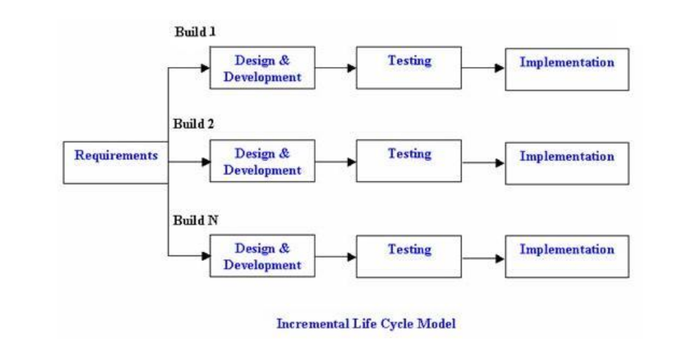

Figure: 1.4.1 Incremental Model

The product is decomposed into a number of components, each of which is designed and built separately (termed as builds). Each component is delivered to the client when it is complete. This allows partial utilization of the product and avoids a long development time. It also avoids a large initial capital outlay and subsequent long waiting period. This model of development also helps to ease the traumatic effect of introducing a completely new system all at once.

### 1.4.2 Data and Information

For every system to be successfully developed and implemented, it requires correct data and information. Data Collection is an important aspect of any type of research study. Inaccurate data collection can impact in the results of a study and ultimately lead to invalid results. In this project the following methods were taken into consideration.

1. Questionnaire method:

I had prepared a questionnaire which had seven to eight questions. Despite their busy schedule, they gave their precious time to fill up the questionnaire. This helped me a lot to know about their views towards the organization and their level of satisfaction.

B) Observation:

Ram Janaki Furnishing and Decoration is not very far from where I stay. I visit them thrice a week and observe the day to day activities. I got a chance to observe the production department and sales department. I got a lot of information by observing them.

C) Personal Interview:

I got a chance to meet the proprietor of an organization. I got to know a lot of information from her including the daily sales amount, monthly profit and many more. Out of 10, 3 of them were interviewed by me regarding the issues of the organization.

### 1.4.3 Feasibility Analysis

A feasibility study aims to objectively and rationally uncover the strengths and weaknesses of an existing business or proposed venture, opportunities and threats present in the environment, the resources required to carry through, and ultimately the prospects for success.

1. Technical Feasibility:

Technical feasibility analysis is done in order to know if the project is technically feasible i.e. if the current state of technology is enough to implement or operate the software. Our web application needs a browser to run the client side of the program and a server system to run the server side program both of which are easily available given the current state of

technology in the world which can also be proved by the fact that there are many web applications out there that are programmed using HTML, CSS,JavaScript and Java, the same languages I am using to build our web application.

B) Schedule Feasibility

Schedule feasibility is concerned with the probability of the project to be

completed within its scheduled time limits, by a planned due date. A project will be unsuccessful if it takes longer time than estimated i.e. if a work to be accomplished at a project doesn’t fit the time frames demanded by its customers, then a schedule is unfeasible.

C) Economic Feasibility

Economic Feasibility studies if the project is within the cost and budget

envisaged by the client. The major cost in my software is the development cost for coding the application. Apart from that a major portion of the cost is used in hosting the database. However the costs does not exceed the budget allocated for the application.

D) Operational Feasibility

Operational feasibility is a measure of how well a proposed system solves the problems, and takes advantage of the opportunities identified during scope definition and how it satisfies the requirements identified in the requirements analysis phase of system development. The users of this developing project are people especially who are busy to go to the shop just to buy some products. However anyone can use the application for their benefit. The signing up for an account is similar to any other web application i.e. the user needs to enter some data like name, age, email etc. Since the application will be easy to navigate the user will learn about it as they go on using it, no special knowledge is needed to use the application. So we can say that the application is operationally feasible.

E) Religious-cultural Feasibility

Religious Cultural feasibility study is defined as one that investigates scientific as well as ethical, behavioral, and social issues that impact the design of the software or application. My application can operate in coordination with our religious and cultural norms and does not have any aspect to upset or offend any religious and cultural groups.

F) Socio-Political Feasibility

Political feasibility analysis is used to predict the probable outcome of a

proposed solution to a policy problem through examining the actors, events and environment involved in all stages of the policy-making process . My application in long run can benefit the society because it helps to grow the society and country economically. Also considering the current socio-political situation of our country, my application is socio-politically feasible.

# Chapter II: Tasks and Activities Performed

## 2.1 Analysis of Tasks & Activities

This portion of report describes the different tasks and activities that are adopted while preparing for the project. After the proposal is accepted on choosing the organization and identifying the topics under which the project is to be conducted, the main purpose of conducting the project effectively and efficiently is that the tasks and activities should be forecasted.

I came with this idea as the owner of the shop is my friend and there were so many problems in the organization.

## 2.2 Analysis of Problems

The main task of Shree Ram Janaki Decoration is to produce various items related to interior designs and furnishings. The day to day producing, selling activity is carried out. This organization buys the old woods,trees and turns them into a fully furnished product.

Every organization has some sort of problems. And obviously it also has many. Among them, the main problems are:

1) There exist no marketing department. They are not able to fulfill their goal of selling their products at every single house.

2) The products over there are not gaining buyer’s attention.

3) Slow buying and selling procedure

4) Niche market

5) Lack of money for hiring highly skilled marketing managers

## 2.3 Analysis of Possible Solution

Out of many problems in this organization, one of the major problem the organization is facing is marketing. The organization is not capable of hiring highly skilled marketing managers. To get rid of this problem, E-commerce can help pretty well. The well integrated system which can be used by many customers. It is feasible to develop the system to solve the existing problems of the organization.

The digital marketing requires no intense knowledge. One who have acquainted secondary level education can solely guide the digital marketing of the organization. Developing E-commerce for this organization will benefit the following aspects:

1) Faster buying/selling procedure as well as easy to find products

2) 24/7 Buying selling

3) More reach to customers, no geographic limitations

4) Low costs and better use of technology

The use cases, ER-Diagram, Class Diagram, Activity Diagram of the proposed system is given below.

### 2.3.1 ER-Diagram

An entity-relationship diagram (ERD) is a data modeling technique that graphically illustrates an information system's entities and the relationships between those entities. An ERD is a conceptual and representational model of data used to represent the entity framework infrastructure.

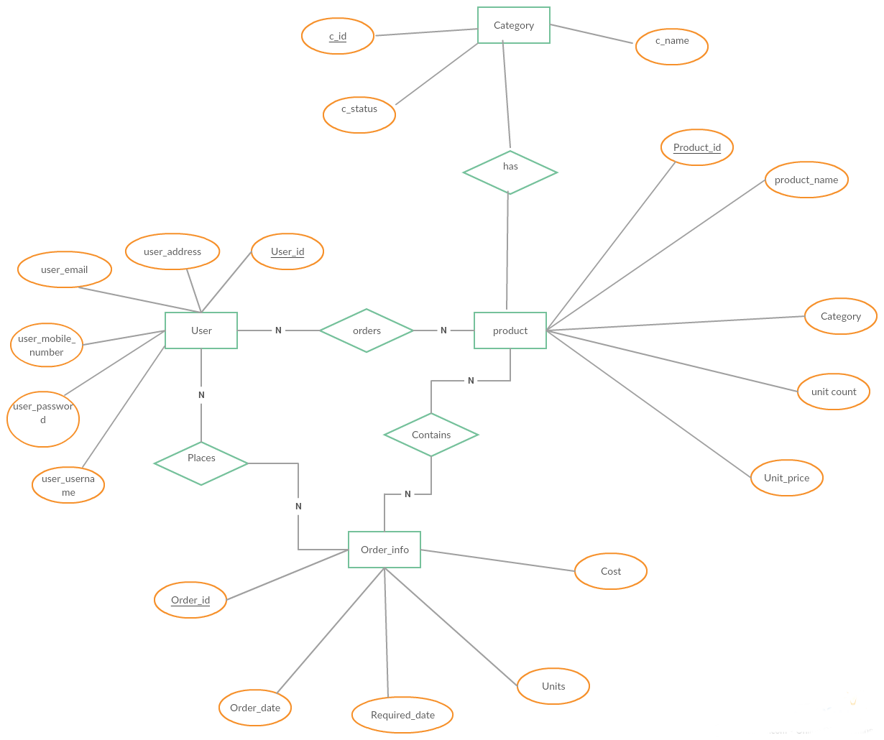

Fig 2.3.1 : ER-Diagram

### 2.3.2 Class Diagram

A class diagram is an illustration of the relationships and source code dependencies among classes in UML. It is used when developing at object oriented system model to show the classes in the system and the association between those classes. When we are developing a model, the first stage usually identify the essential object and represent them in a class. The class diagram is shown in the figure as:

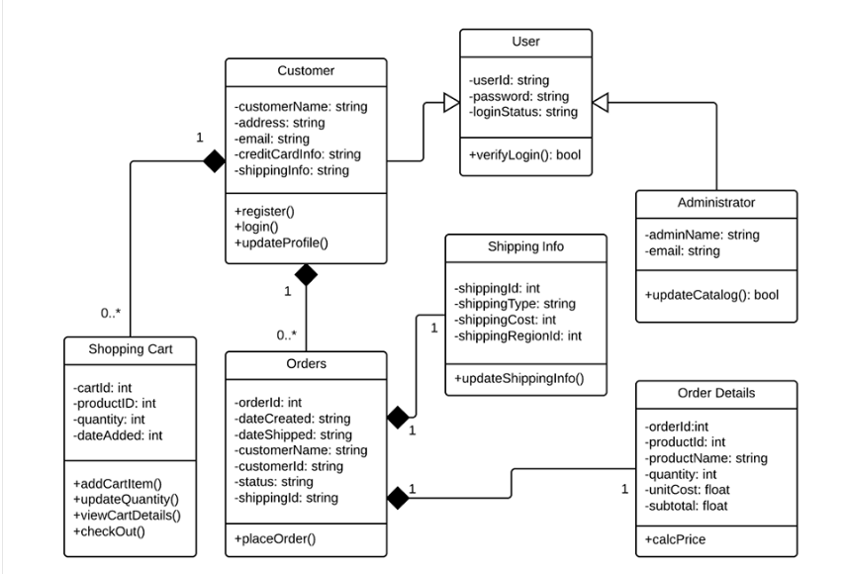

Figure: 2.3.2 Class Diagram of Ecommerce

### 2.3.3 Use Case

A use-case diagram at its simplest is a representation of a user's interaction with the system that shows the relationship between the user and the different use cases in which the user is involved. A use case diagram can identify the different types of users of a system and the different use cases and will often be accompanied by other types of diagrams as well.A use case diagram that represents the system is shown in the following figure:

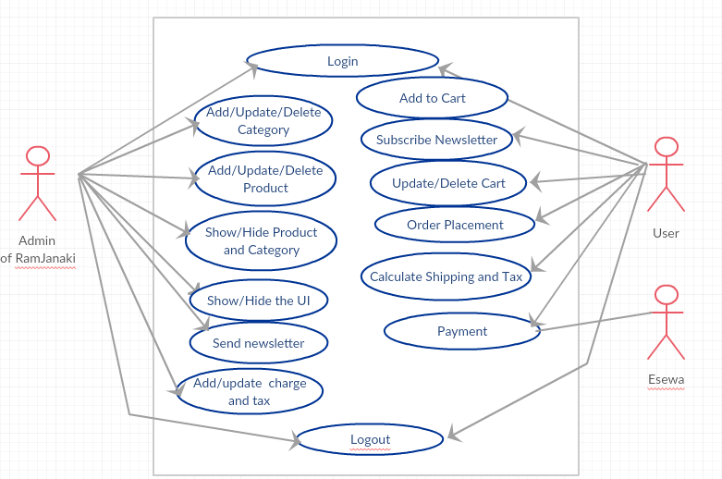

Fig 2.3.3 Use Case of Ecommerce on RamJanaki

### Admin :

### The admin of the proposed web application is responsible for adding, viewing and deleting the category of products. He/She can also enable or disable the category so that the user will view it in the UI. He/She is also responsible for editing the product, adding the product and enabling or disabling the product. All the products that are enabled by the admin are only shown in the UI part. The admin is also responsible for sending the newsletter to the subscribed email users weekly.

User:

The users are the main attraction of this web application. The users can signup and login in this web application. The authorized users are only allowed to add, update and delete their carts. They are also allowed to place their order. They can subscribe to the newsletter if they want. They will receive emails weekly. They can pay the money with the help of payment gateway.

### Esewa:

Esewa is the payment gateway system in our country. One can use it to pay the price of the product through my web application.

### 2.3.4 Sequence Diagram

It is used to model interaction between a component, although external agent may also be included. It in the UML are primarily used to model the interaction between the actors and object in the system and the interaction between objects themselves. A sequence diagram shows the sequence of interaction that take place during particular use case.

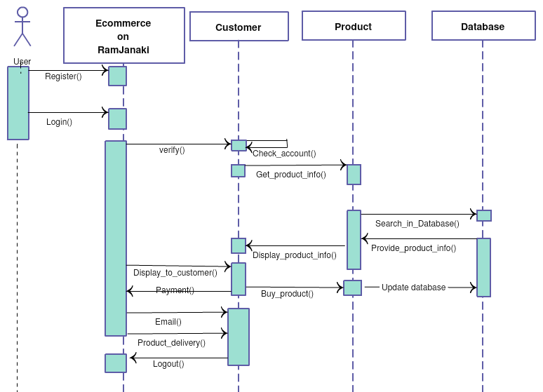

Fig: 2.3.4 Sequence Diagram of Ecommerce on RamJanaki

### Tools Used

From among the various tools and techniques available, I have used the tools that is suitable for such type of project. The ecommerce project must be more secure as it has payment gateway service. The tools and techniques that I have used in my project are as follows:

* Frontend: HTML, CSS, Bootstrap, JQuery
* Backend: Java
* Build Tool: Maven
* Version Control System: GIT
* Frameworks: Spring Framework, Hibernate (ORM)
* IDE: Intellij Idea
* Database: MYSQL
* Services: Payment Gateway(Esewa), Google reCaptcha, JavaMail API etc